# Target Metrics

Overall - Accuracy: 0.5200, Precision: 0.8188, Recall: 0.5200, F1: 0.6317

Class-specific metrics:

Carbon neutral(ity) - Precision: 0.7059, Recall: 0.4800, F1: 0.5714

Emissions reduction target - Precision: 0.7692, Recall: 0.4000, F1: 0.5263

N/A - Precision: 0.0000, Recall: 0.0000, F1: 0.0000

Net zero - Precision: 0.8000, Recall: 0.6400, F1: 0.7111

No target - Precision: 1.0000, Recall: 0.5600, F1: 0.7179

# Year Metrics

Overall - Accuracy: 0.5800, Precision: 0.5823, Recall: 0.5800, F1: 0.5741

Class-specific metrics:

- Precision: 0.0000, Recall: 0.0000, F1: 0.0000

2020 - Precision: 0.5000, Recall: 1.0000, F1: 0.6667

2021 - Precision: 0.0000, Recall: 0.0000, F1: 0.0000

2022 - Precision: 0.0000, Recall: 0.0000, F1: 0.0000

2023 - Precision: 0.0000, Recall: 0.0000, F1: 0.0000

2025 - Precision: 0.5000, Recall: 0.6000, F1: 0.5455

2030 - Precision: 0.7097, Recall: 0.8800, F1: 0.7857

2031 - Precision: 0.0000, Recall: 0.0000, F1: 0.0000

2031-32 - Precision: 0.0000, Recall: 0.0000, F1: 0.0000

2032 - Precision: 0.0000, Recall: 0.0000, F1: 0.0000

2033 - Precision: 0.0000, Recall: 0.0000, F1: 0.0000

2035 - Precision: 0.8333, Recall: 1.0000, F1: 0.9091

2040 - Precision: 1.0000, Recall: 0.8000, F1: 0.8889

2050 - Precision: 0.8636, Recall: 0.7037, F1: 0.7755

No target - Precision: 0.0000, Recall: 0.0000, F1: 0.0000

None - Precision: 0.0000, Recall: 0.0000, F1: 0.0000

# Other Metrics

Quote Accuracy: 0.4000

Overall Accuracy: 0.3400

Valid XML Percentage: 1.0000

# Confusion Matrices

Target Confusion Matrix:

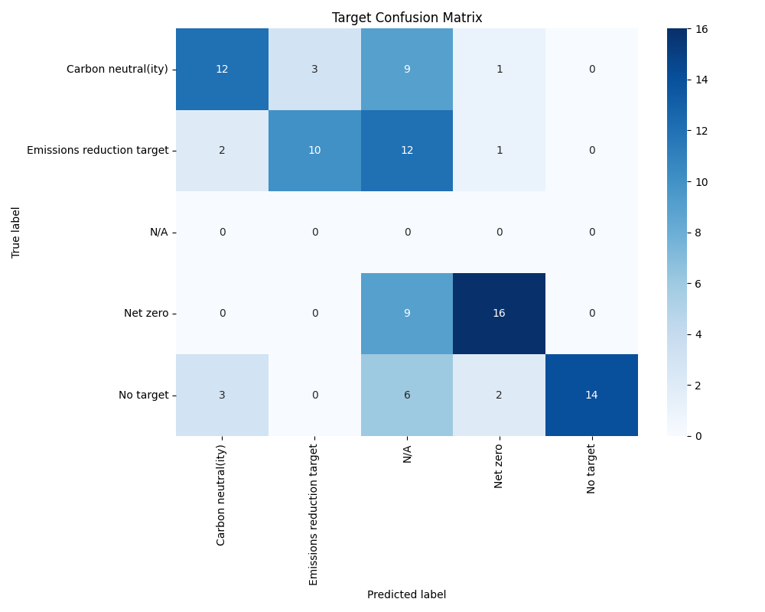

Year Confusion Matrix:

